# Exercise: HTML and CSS: Tags and Selectors

## Welcome to HTML

Create a Web Page like the following:

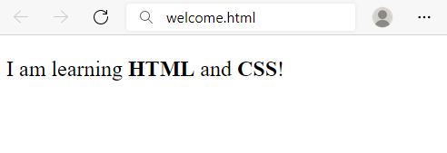

Create file named welcome.html. Use the texts from the filesite-texts.txt.

### Requirements

* Title: Welcome
* <strong> tag for **bold** text
* <p>tag for paragraph

## Fruits

Create a Web Page like the following:

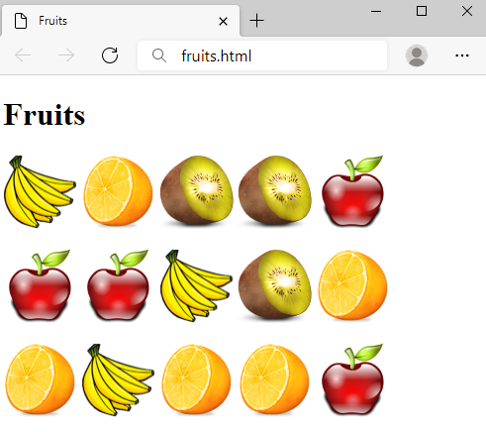

Create a file fruits.html.

### Requirements

* Titile: Fruits
* <h1> tag for **heading**
* <img> tag for **images**

### Hints

* Use 3 **paragraphs**, each holding 5 images

## Wiki Page

Create a Web Page like the following:

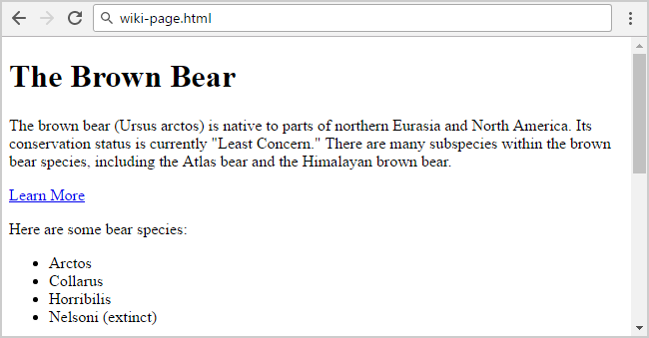

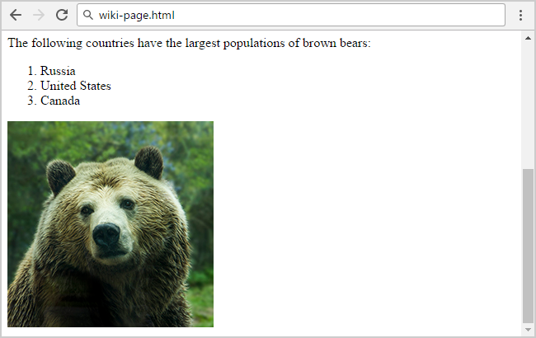

Create file: wiki-page.html. Use the texts from the filesite-texts.txt.

### Requirements

* Title: **The Brown Bear**
  + <h1> for heading
* Hyperlink: <https://en.wikipedia.org/wiki/Brown_bear>
* Text: **use paragraph**
* List: **use ordered list** and **unordered list**
* Image: bear.jpg

## To Do List

Create a Web Page like the following:

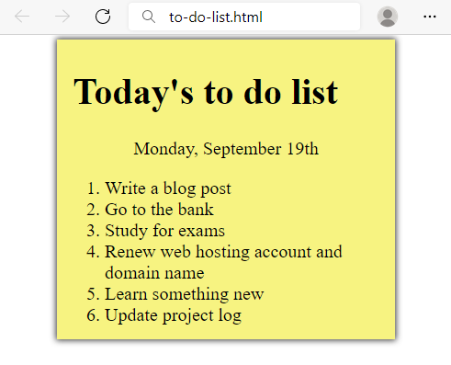

Create two files: to-do-list.html and to-do-list.css. Use the texts from the filesite-texts.txt. Set the html title to be the same as the task name.

### Requirements

* **<main>** with **class="my-list"** as container
  + Background Color: **#f7f381;**
  + Padding: 8px 24px;
  + Width: 500px;
  + Text size: 30px;
  + Border: 1px solid #f7f381;
  + box-shadow: 0 0 10px 2px #333333;
* <ol>
  + Margin: 12px;
* <p>
  + Center the text

### Hints

* Center the **container**
* Heading: use <h1>
* Date: use <p> + center it
* List: use <ol>

## Navigation Bar

Create a Web page, holding like the following navigation bar:

Картина, която съдържа текст, екранна снимка, Шрифт

Описанието е генерирано автоматично

Use the texts from the filesite-texts.txt.

Create two files: nav-bar.html and nav-bar.css.

### Requirements

* <body>
  + Margin: 0px;
  + Padding: 0px;
  + Background Color: #CCCCCC
* <nav>tag as container
* <ul> tag for unordered list
  + Background Color: #444
  + Center the text
  + Padding: 0px
  + Margin: 0px
  + list-style:none
* <li> tag for list item
  + Text size: 24px
  + Line Height: 40px
  + Height: 40px
  + Padding: 20px
* <a> tag for hyperlink
  + text-decoration: none
  + Text-Color: #ffffff

### Hints

Use:

* <li> with display:inline-block

## Page Content

Create a Web page like the show below, using the text from the filesite-texts.txt.

Картина, която съдържа текст, екранна снимка, Шрифт, номер

Описанието е генерирано автоматично

Create two files: page-content.htmlandpage-content.css**.**

### Requirements

* <section>as a container
* <article>tag for content
  + <header> with:
    - <h1>Text size: 28px
    - <p>Font Style: **italic**
* <p>
  + Text size: 24px
* <body>
  + Margin: 0px
  + Padding:0px
  + Background color: **#CCCCCC**
* **<section>**
  + Margin Left: 20px

## Semantic Blog Layout

Create a **blog layout page**, which holds **header**, **footer** and **main**. The **main** should hold two **sections**, each holding two **articles**. It should look like this (without any styling):

Картина, която съдържа текст, екранна снимка, Шрифт, номер

Описанието е генерирано автоматично

Картина, която съдържа текст, екранна снимка, Шрифт, номер

Описанието е генерирано автоматично

Use the texts from the filesite-texts.txt.

Create files: index.htmlandstyles.css.

### Requirements

* The title should be "**Semantic Blog Layout**"
* Use header tag for the header section
  + Use h1 tag for the heading
  + Use nav tag for the navigation with an unordered list (ul) inside
    - Create two **list** items with **anchor** (a) tags inside
* Use main tag for the page main content
  + Create two **sections** in the main. Each section has:
    - A **header** with h2 heading
    - Two **articles** with h4 heading and three p tags inside
    - For the dates use time tag
* Use footer tag with **two** paragraphs Inside
  + Use **anchor** tag for the name in the last sentence

### Add CSS Styling

Add **CSS styling** to make the blog look better, like at the following screenshot:

Картина, която съдържа текст, електроника, екранна снимка, Шрифт

Описанието е генерирано автоматично

Create files: index.htmlandstyles.css.

Use the following **CSS styles** to make your HTML look like at the screenshot:

|  |
| --- |
| header {      border-radius: 3px;      padding: 8px 10px;      background-color: #dceaf4;      border: 1px solid #bfcacb;  }  header * {      display: inline;      vertical-align: middle;  }  nav ul {    margin: 0;    padding: 10px;  }  nav li {    margin:10px;  }  nav li a {      text-decoration: none;  }  body{      background-color:#b7d7e8;  }  section h2 {      margin: 15px 10px;  }  article {      display: table-cell;      width: 50%;      padding: 10px 15px;      background-color: #e5f0f7;      border: 10px solid #b7d7e8;  }  footer {      margin: 5px;      padding: 5px 10px;      border-radius: 3px;      background-color: #dceaf4;      border: 1px solid #bfcacb;  }  footer p {      margin: 5px;  } |

## Restaurant Menu

Create a web page like the following:

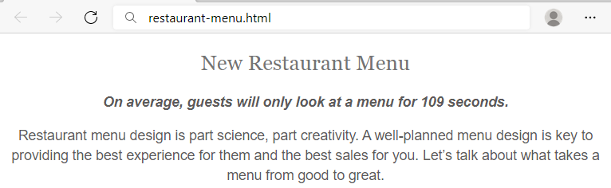

### Requirements

HTML with <body> that contains: <article>, <h1>, <span> and <p>.

CSS:

* <body>
  + Align the **text** to the **center**
* <h1>
  + Fonts: **Sentinel** **A**, **Sentinel** **B**, **Georgia**, **Times** **New** **Roman**, **Times**
  + Generic Font: **serif**
  + Font weight: **400**
  + Height of the line: **1.15**
  + Text color: #**747474**
* <span>
  + Fonts: **Graphik** **Semibold** **Web**, **Open** **Sans**, **Helvetica** **Neue**, **Helvetica**, **Arial**
  + Generic Font: **sans-serif**
  + Font style: **oblique**
  + Font weight: **600**
  + Font size: **16px**
  + Height of the line: **1.46**
  + Text color: **#5c5a5a**
* <p>
  + Fonts: **Graphik** **Regular** **Web**, **Helvetica** **Neue**, **Helvetica**, **Arial**
  + Generic Font: **sans-serif**
  + Font weight **400**
  + Font size: **16px**
  + Height of the line: **1.46**
  + Text color: **#5c5a5a**

## Style Lists

Create a web page like the following:

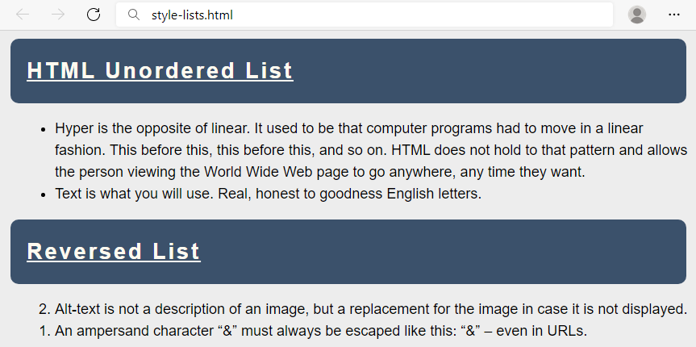

### Requirements

You will be given a skeleton with **filled** **HTML** and an **empty** **CSS** file. Write the missing **CSS** following the guidelines in the task.

* <body>
  + Font: **Helvetica**
  + Generic Font: **sans-serif**
  + Height of the line: **1.5**
  + Font size: **18px**
  + Background color: **#EDEDED**
* <h2>
  + Decorate the text with underline
  + Paddings: **20px**
  + **Top** & **bottom** margin **10px**
  + **Left** & **right** margin **5px**
  + Space between letters: **3px**
  + Background color: **#3B516B**
  + Radius of the border: **10px**
  + Text color: **floralwhite**
* <li>
  + Left margin: **20px**

## Styling Tables

Create a web page like the following:

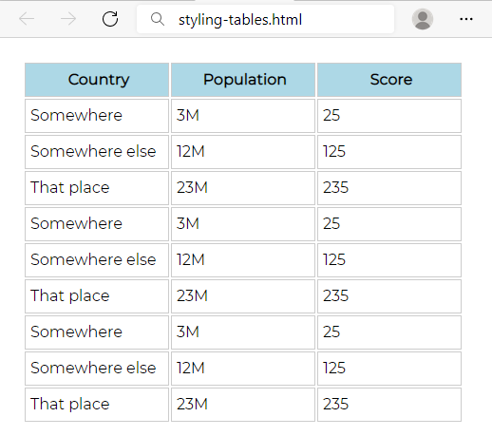

### Requirements

You will be given a skeleton with **filled** **HTML** and an **empty** **CSS** file. Write the missing **CSS** following the guidelines in the task.

* <body>
  + Font: **Montserrat**
* Use CSS import: @import 'https://fonts.googleapis.com/css?family=Montserrat';
  + Generic Font: **sans-serif**
  + Paddings: **16px**
* <th>
  + Background color: lightblue
* <th> and <td>
  + Width: **144px**
  + Height: **32px**
  + Solid border with size 1px and color #ccc
  + Left padding: **5px**

## Buttons CSS

Create a web page like the following:

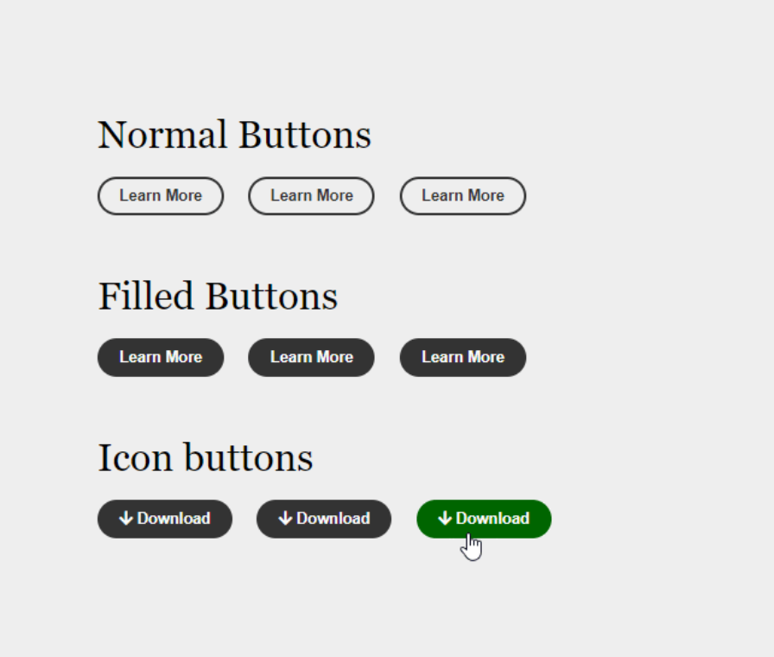

### Requirements

* Create an **"**index.html**"** file with title - **"**Buttons CSS**"**
* Use h2 tag for headings
  + **font-family: Arial, Helvetica, sans-serif;**
* Create 9 buttons on 3 rows with class button
  + For the first button in each row use a tag
  + For the next two buttons in the row use button tags
  + The buttons in the second and the third row should have class - fill
  + Every last button in the row should have class - hover
* You must use the following three colors:
  + green(rgb(0, 102, 0))
  + white(rgb(251, 251, 251))
  + gray(rgb(51, 51, 51))
* Use **FontAwesome** for this task. Import it in your CSS, with the **@import** rule.
* CSS
  + **h2**
    - Set **font-family** to **Arial, Helvetica, sans-serif**
  + **• a, .button**
    - * Border: **2px solid black**
    - Border Radius
      * Use a **15px border-radius**
    - Padding: **8px 15px**
    - Font-Family: **Arial, Helvetica, sans-serif**
    - Font Size: **14px**
    - Text Color: **rgb(51, 51, 51)**
    - Background Color: **white**
    - Font Weight: **bold**
    - Margin: **5 px**
    - Text Decoration: none
  + **.fill** 
    - Background Color: **black**
    - Color: **rgb(251, 251, 251)**
  + **Hover States**
    - **.button.fill.hover:hover**
      * Background color: **rgb(0, 102, 0)**
      * Color: **white**
    - **.button.hover:hover:**
      * Color: rgb(0, 102, 0)
  + **• <i> with class .fa-arrow-down**
    - Color: **white**
    - Right Padding: 5px

### Hints

* Change the **cursor** property to [pointer](https://www.w3schools.com/cssref/pr_class_cursor.asp)
* Change the **outline** property to [none](https://www.w3schools.com/Css/css_outline.asp)
* **FontAwesome:** **https://use.fontawesome.com/releases/v5.6.3/css/all.css**

## Font Awesome Icons

Create a web page like the following:

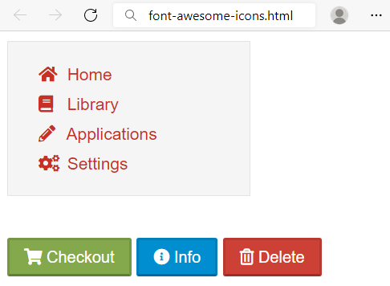

### Requirements

HTML with <body> that contains: <nav> and separately <p>

* <nav> with
  + <ul> and in it
    - <li> and in it
      * <a> and in it
        + <i> + text
* <p> with three buttons
  + <button> with class="shopping"
  + <button> with class="info"
  + <button> with class="delete"

CSS:

* Import font awesome link
* <body>
  + Fonts: **proxima-nova**, "**Helvetica** **Neue**", **Helvetica**, **Arial**
  + Generic Font: **sans-serif**
* <nav>
  + Width: 200px
  + Solid border with size 1px and color #e3e3e3
  + Font size: **14px**
  + Height of the line: 20px
  + Background color: #f5f5f5
* <li>
  + None list style
  + Height of the line: 25px
  + Left margin: -15px
* <a>
  + None text decoration
  + Text color #c83025
* <i>
  + Width: 1.14em
  + Right padding: 0.28em

For all the **buttons**

* **Top** & bottom padding 4px
* **Left** & **right** padding 12px
* Height of the line: 20px
* Text color: #ffffff
* Border color: rgba(0, 0, 0, 0.1) rgba(0, 0, 0, 0.1) rgba(0, 0, 0, 0.25)
* Cursor: pointer

For the **button.shopping**:

* Background color: **#83a94c**

For the **button.info**:

* Background color: **#008ed0**

For the **button.delete**:

* Background color: **#cc4036**

## Icon Font Buttons

Create a web page like the following:

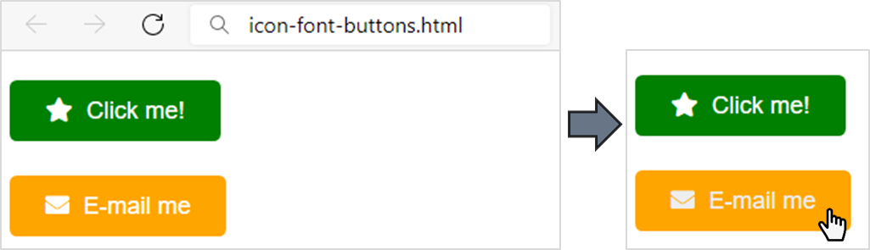

### Requirements

You will be given a skeleton with **HTML** and an **empty** **CSS** file. Write the missing **CSS and HTML** following the guidelines in the task.

Add icons with the following classes in the **HTML** <a> tag: fas fa-star, fas fa-envelope.

* <body>
  + Font: **Arial**
  + Generic Font: **serif**
  + Height of the line: **3**
  + Font size: **18px**
* <a>
  + **None** text decoration
  + Text color: **#fff**
  + Set the border radius to **5.40px**
  + **Top** & bottom paddings 12.6**px**
  + **Left** & **right** paddings 27px
* When the mouse course is over (a:hover):
  + Change the **text color** to **#eee**
* <i>
  + Right padding: **5.40px**
* The **anchor** with class="green" (you can select them like that: .green)
  + Background color: green
* The **anchor** with class="orange" (you can select them like that: .orange)
  + Background color: orange
* Use **FontAwesome** for this task. Import it in your CSS, with the @import rule